Deep Learning Approaches for Egg Crack Detection: A Comparative Study Using CNN, ResNet, and Xception Models

1st Kuruva Vamsi
School of Computing
VFSTR Deemed to be University
Guntur, India
vamshiraj491@gmail.com
4th Sujatha Kamepalli
School of Computing
VFSTR Deemed to be University
Guntur, India
sujatha_kamepalli@yahoo.com
2nd Bommisetty Swathi
School of Computing
VFSTR Deemed to be University
Guntur, India
bommisettyswathi@gmail.com
3rd Kolisetty Vijay
School of Computing
VFSTR Deemed to be University
Guntur, India
vijaykolisetty87@gmail.com

Abstract—In the food industry, egg crack prediction is crucial for ensuring the quality and safety of eggs before they are eaten. It allows for real-time egg sorting and monitoring, improving the production process’s productivity and cost-effectiveness. we collected images of both damaged and undamaged eggs and significantly expanded our dataset through data augmentation techniques. By expanding the dataset, this method improved the model’s capacity to forecast egg breaks with accuracy. We performed preprocessing using data augmentation, scaling, and normalization on the gathered photos of both injured and undamaged eggs. These processed images were then fed into various deep learning models, including CNN, ResNet, and Xception. ResNet achieved the highest accuracy of 98.75 percent in predicting egg cracks. These results underline the value of dataset augmentation in enhancing model accuracy and demonstrate the efficacy of deep learning models in quality control within the egg business. Furthermore, the study also shows how crucial dataset augmentation is to raising machine learning models’ accuracy in identifying egg breaks. Future research on the creation of efficient machine learning models for the early identification and quality control of egg cracks can build on the results of this work.

Keywords—Deep Learning, Convolutional Neural Networks (CNN) , ResNet , Xception ,Egg Crack Detection, Image Processing ,Data Augmentation, Machine Learning, Quality Control ,Computer Vision

Introduction
Eggs are one of the most important foods in our daily nutrition. It is a good source of proteins, minerals and vitamins. Eggs are produced by domesticated birds such as chickens, ducks and quails. Their unique composition includes the yolk, which contains proteins, fats and other essential nutrients, the egg white or albumen, which is mostly water and proteins. Eggs continue to be a versatile and indispensable ingredient in kitchens. In respond to increase the egg consumption, the capacity increase in farms and many machines are developed due to increase in high production capacity. These machines also sort eggs by weight condition, identifying and removing those are dirty, bloody, broken, or cracked. Cracks in eggshells, which can occur during handling and packaging, make eggs susceptible to harmful microorganisms, posing health risks and compromising food safety. To eliminate or minimize these problems caused by cracked eggs, it is important to separate
the normal eggs and cracked eggs at production level. A mix of strategies, such as methodical sorting, efficient handling techniques, early detection, and correct diagnosis, are needed to manage egg crack detection effectively. Product quality and safety may be improved, customer satisfaction can rise, and the detrimental effects of cracked eggs on the food business can be reduced with the development and application of efficient detection techniques. With the ability to create precise and effective detection models from the massive volumes of data produced by contemporary monitoring technology, machine learning has become a potent tool for egg crack detection. The ultimate objective of using machine learning models to egg crack detection is to deliver prompt and precise diagnoses that can aid in the prevention of quality problems and enhance the productivity and economics of egg manufacturing procedures.​

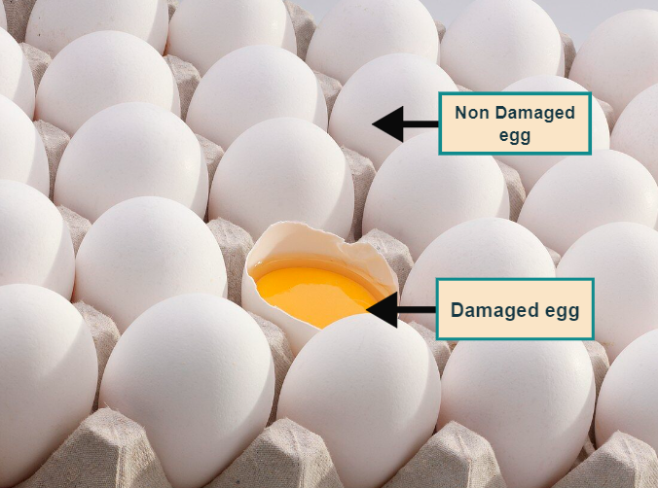
Fig. 1. Identification of Damaged and Non-Damaged Eggs

To identify egg cracks using images, we used a variety of deep learning algorithms in this research study. We gathered pictures of both broken and undamaged eggs, then we used data augmentation methods to increase the size of our dataset. The model's prediction accuracy for egg breaks was enhanced by the supplemented dataset. Scaling and normalization were used as preprocessing steps before the images were fed into CNN, ResNet, and Xception, among other deep learning models. ResNet outperformed the other models in predicting egg breaks, with an accuracy of 98.75%. The outcomes show how useful deep learning models are for quality control in the egg business and highlight the significance of dataset augmentation in improving model accuracy. The Xception model demonstrated promising results with an accuracy of 89.35%, as demonstrated by our comparison analysis of these models to increase egg production's economy and efficiency. This work establishes the foundation for further investigations into the creation of effective machine learning models for the early identification and quality assurance of egg cracks. This synergistic approach enables us to achieve robust and accurate egg crack detection results within the Egg Crack Detection. Furthermore, improvements in machine learning for egg crack prediction have gone beyond just identifying visible fractures to include other quality concerns like bloodstains and illnesses in the eggs. Future developments in this area may make better use of sophisticated machine learning methods to anticipate different egg abnormalities and illnesses.

Structure of the paper
The significance of automated egg-based food items and the function of egg crack detection in guaranteeing product quality, safety, and customer happiness are covered in the introduction. It presents the difficulties in shipping eggs as well as the possible financial losses from cracks and fractures. The cutting-edge technology of Egg Crack Detection, which uses sophisticated computer vision and machine learning algorithms to pinpoint the ideal cracking places, is also highlighted in this section.

Objectives
- To examine the deep learning models used for detecting egg cracks.
- To create deep learning models capable of accurately detecting egg cracks.
- To assess the accuracy of the deep learning models in identifying egg cracks.
- To examine the efficiency of various image pre-processing approaches.
- To predict whether a given egg is cracked or not.
- To evaluate the impact of the dataset on the performance and robustness of the deep learning models.

RELATED WORK
The main objective of this study is to categorize images of eggs using deep learning models. This work is distinct from all others we have used your dataset and employed data augmentation techniques bespoke CNN and advanced pre-trained models, such as Xception and Inception ResNet V2, to obtain excellent classification accuracy. [1] The proposed training criterion for deep neural networks aims to maximize interval minimum classification error by using insights from error backpropagation analysis. We test a novel approach termed M3CE-CEc, which combines cross entropy (CE) with Maximum Interval Minimum Classification Error (M3CE), using two popular deep learning databases: MNIST and CIFAR-10. The findings demonstrate that M3CE is a beneficial addition to the present standards and helps enhance CE. Remarkably, M3CE-CEc yields positive outcomes in both databases. Deep convolutional neural networks, or CNNs, are very good at identifying distortion-invariant images because they use feature detection layers to implicitly learn from the input. By allowing neurons on the same feature mapping surface to share weights, weight sharing makes it easier to extract features efficiently in parallel computing. CNNs resemble biological brain networks more than traditional networks but with fewer parameters and less computational complexity. Weight sharing considerably simplifies network structure by avoiding the complexities of data reconstruction during feature extraction and classification, particularly when processing multi-dimensional input vector images (WDIN). Despite their advantages, CNNs are sometimes seen as ”black box” models for feature extraction. Examining the relationship between CNN layers and the human visual nerve system is essential to replicating human learning mechanisms for incremental knowledge and targeted object comprehension. This highlights the need for additional research on progressive learning techniques that mimic hu- man thought processes and CNN layer interconnection.[2] The growth of neural networks from a few layers to dozens or even hundreds of layers demonstrates their capacity to convey extraordinarily complex tasks. Deep networks are very good at learning features at different levels of abstraction. They can recognize more complicated edge features at higher levels of abstraction than simple ones at lower levels. Never the less, a significant challenge that frequently keeps them from functioning properly is the vanishing gradient problem. In highly deep networks, gradient signals rapidly decay, impeding gradient descent and leading to slow convergence. Gradient descent is defined by the exponential decay of gradients, whereby signals diminish in the direction of zero as a result of the weight matrices being multiplied during backpropagation. Even though gradient explosion where gradients expand un- controllably is rare, gradient vanishing is the primary issue. Consequently, when network depth increases, As the gradient drop rate rises, training deeper networks gets more difficult. The emergence of residual networks, which enable the training of deeper networks, has fundamentally altered this scenario. By including skip connections that ignore particular layers, residual networks address the problem of vanishing gradients and enable the training of networks with previously unheard- of depth. This research proposes a neural network model for picture recognition based on deep learning aspects autonomously, eliminating the need for human and subjective feature selection. The experimental results validate the method’s resilience and accuracy and show that it can both survive noise pollution and enhance picture identification accuracy. by following academic rules, utilizing precise technical jargon, and properly formatting paragraphs and quotes. It maintains a compelling plot, inventive thoughts, and a high writing standard. The language is exact and unambiguous, offering a thorough and succinct defence of viewpoints and arguments. Our objective is to increase the classification accuracy of benign and malignant gastric ulcer lesions in endoscopic images of the digestive system, particularly in scenarios when available data is limited. To do this, we combine a residual attention mechanism, convolutional neural networks (CNNs), and the Xception model. Before submitting the images to our Py-Torch based algorithm, we preprocess the images using techniques like the Sobel operator to address problems like uneven illumination and low picture resolution.[3] Our approach significantly improves the diagnostic performance of the Xception model. After applying the residual attention module, we observed notable gains in accuracy (81.411), F1 score (81.815), sensitivity (83.751), specificity (76.827), and precision (80.111). This illustrates how well feature learning may be improved using residual attention. Our objective is to increase the classification accuracy of benign and malignant gastric ulcer lesions in endoscopic images of the digestive system, particularly in scenarios when available data is limited. To do this, we combine a residual attention mechanism, convolutional neural networks (CNNs), and the Xception model. Before submitting the images to our Py-Torch -based algorithm, we preprocess the images using techniques like the Sobel operator to address problems like uneven illumination and low picture resolution. Our study has important implications for improving screening skills since gastroscopic screening is essential for the early diagnosis of stomach cancer, particularly in primary hospitals where data availability may be constrained. CAD (Computer-Aided Diagnosis) systems are one example of how deep learning and machine learning technologies can be used to bridge the gap in screening capability and support early detection efforts. Our findings provide important insights for the deployment and uptake of new diagnostic technologies in primary medical settings, in addition to helping to improve diagnostic accuracy.[4] This paper proposes a three-row egg conveyor, dynamic photographs of preserved eggs were taken for this study, maintaining fixed positions for each station. Based on the fixed station, these photos were then divided into separate preserved egg images. Matrix and sequential splicing approaches were used to join photos of the same preserved egg that were in four adjacent photographs. Several deep-learning classification models were trained and evaluated for detection efficiency and speed using these spliced images as datasets. According to the results, MobileNetV3large functioned best Subsequent studies investigated the impact of splicing systems and picture dimensions on detection efficiency and speed, the matrix splicing scheme with a 224 × 224 pixel image size was found to be the most effective. A refined version of the MobileNetV3large model was created using merely 1.644 × 106 parameters, attaining a 96.3 accuracy rate and a detection time of 4.267 s for 300 pictures. Their approach can detect cracked preserved eggs with excellent accuracy and doesn’t require a lot of processing resources, making it ideal for high-throughput online detection.[5] This study introduces a novel method for automated detection of cracks on eggshells using a convolutional neural network (CNN). The CNN model was trained on image patches extracted from egg images, with experimentation revealing that a batch size of 64 yielded the best results. The CNN model significantly outperformed support vector machine (SVM) classifiers trained on histogram of oriented gradients (HOG) and local binary pattern (LBP) features, achieving precision, recall, accuracy, false positive rate (FPR), and area under the curve (AUC) of 98.28 accuracy,92.41 accuracy, 96.92 accuracy, 0.81 accuracy, and 99.53 accuracies, respectively, in classifying image patches. Furthermore, the CNN model demonstrated superior performance over SVM models in classifying entire egg images, achieving an accuracy of 95.38. Unlike traditional techniques that require manual feature extraction for classification, the CNN in this study automatically extracts relevant features, enhancing efficiency. This approach focuses on specific image patches rather than analysing entire images, leading to faster and more memory- efficient crack detection. The low FPR values indicate a minimal risk of misclassifying intact eggs as cracked, reducing waste. This method lays the groundwork for future studies to develop an online crack detection process using video footage of rotting eggs. Additionally, their approach is adaptable for use with various types of eggs for crack detection purposes.[6] The automatic separation of faulty from quality eggs is a key issue that needs to be addressed for both food safety and economic reasons. To identify cracked, bloody, and filthy eggs, a deep learning-based real-time machine vision system was created. All of the egg’s surfaces could be seen thanks to a constant rotating system that made it possible to keep an eye out for unfavourable elements including blood, grime, and cracks on any surface. For effective categorization, the suggested system makes use of a Sequential Multiple Image-based Convolutional Neural Network-Bidirectional Long-Short-Term-Memory (SMI-CNN-Bi-LSTM) model. Using a pre-trained residual network (DenseNet201) model, deep features are collected from egg pictures and put into the Bidirectional Long-Short-Term-Memory (Bi-LSTM) for classification. According to experimental results, the suggested model’s accuracy of 99.17 accuracy score, surpassing current cutting- edge techniques. The ability to view the entire egg, making defects easily visible, the use of a vacuum arm system to separate faulty eggs without the need for human intervention, and the model’s efficiency in identifying faulty eggs through the use of deep features and Bi-LSTM are some benefits of the suggested method. In their future studies, the dataset will be expanded utilizing data augmentation algorithms, enriched with various photos of faulty eggs, and further examined with a focus on feature selection and reduction techniques for enhanced feature extraction. [7] the dataset will be expanded utilizing data augmentation algorithms, enriched with various photos of faulty system’s precision in differentiating between edible and non- consumable eggs.[8] The goal of this work is to identify egg cracks by applying the Efficient Net model and a 6-position egg image acquisition technique. To improve the effectiveness of model training, the CIFAR-10 dataset is used to pre-train the model using transfer learning. This initializes the weights. When the efficacious Net model’s performance is juxtaposed with that of other CNN models, such as AlexNet, VGG16, and ResNet50, it is evident that the former performs noticeably better than the latter, averaging an accurate recognition rate of 98.6 In particular, the EfficientNetB2 model shows the best overall performance for egg crack detection, with a correct recognition rate of 99.5 with only 29 minutes of training. Additionally, the study investigates various learning rates for the EfficientNetB2 model and discovers that the optimal results are obtained at a learning rate of 0.001 execution. Overall, this study’s improved model shortens the time needed for model training while improving the accuracy of egg crack detection. This paper highlights the efficacy of combining transfer learning with deep learning in CNN modelling by providing an efficient method for egg crack detection using the Efficient Net network model and transfer learning.

METHODOLOGY
A benchmark dataset wasn’t accessible for the research. Instead, we have taken 794 images of damaged and non- damaged eggs collected from various sources on the internet. To increase the size of the dataset we performed some data augmentation techniques that include operations like random rotation (0-45 degrees), width and height shifts (up to 20 percent), shearing (0.2 max), zooming (0.2 max), horizontal flipping, and filling new pixels with a constant value (125), enhancing the dataset with 1438 images, and performed pre- processing for the dataset. Further, we have divided the dataset into training and testing. To perform classification and predict whether the egg is damaged or non-damaged we used several deep learning models such as “Customized CNN Model, ResNet, and Xception” for classification. We used metrics such as accuracy, precision, recall, and the F1-score to evaluate the performance for these models.
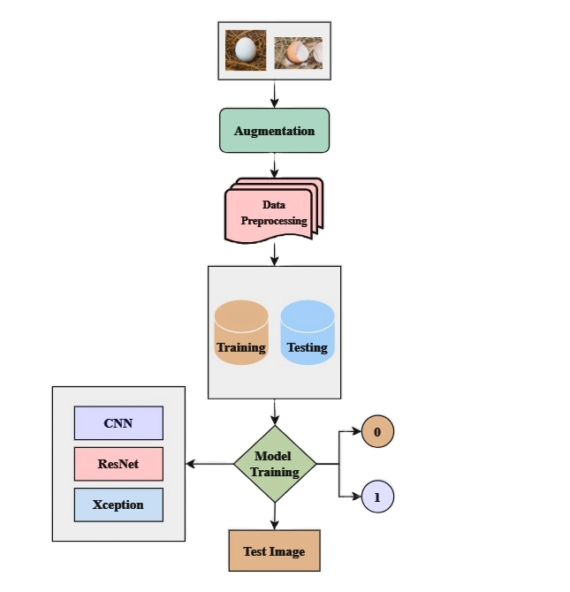
Fig. 2. Flow of the work

The figure shows a detailed flowchart of an egg picture classification process, beginning with input images that are augmented to diversify the dataset, the following preprocessing, the enhanced photos are divided into training and testing sets. CNN, ResNet, and Xception are a few examples of deep learning architectures that are used during the model training phase.

Convolution Neural Network (CNN)
CNNs (Convolutional Neural Networks) are crucial for image classification due to their ability to automatically learn and extract features from images. They excel at capturing hierarchical patterns and spatial dependencies present in visual data, making them highly effective for tasks like image classification. When applied to egg classification, CNNs can analyse both damaged and non-damaged egg images, learning discriminative features that distinguish between the two classes. The CNN model to be proposed for the purpose of image classification would be a sequential model with a 2D convolutional layer at the beginning, having 32 filters of 3x3, activated by ReLU, and an input shape of 299x299x3. A max-pooling layer of 2x2 is applied thereafter to reduce spatial dimensions. Next in line are two more convolutional layers with 64 filters, followed by another pair of convolutional layers with 64 filters; all of these have ReLU for inducing non-linearity. It adds a flattening layer to be applied after feature extraction. It converts the 2D matrix data into a 1D vector. After that, there is a dense layer of 64 neurons activated by ReLU; this is succeeded by the last dense layer with 2 neurons activated by sigmoid for class probability output. Finally, the model is compiled using the Adam optimizer with the Sparse Categorical Cross-entropy loss function, along with an accuracy metric. An early stopping callback is added to stop the training in case the loss does not decrease for three consecutive epochs, hence avoiding overfitting. It trains with a validation dataset for epochs 13 times and brings out the final training accuracy to approximately 92% and the test accuracy to 91%, hence good for an image classification task.
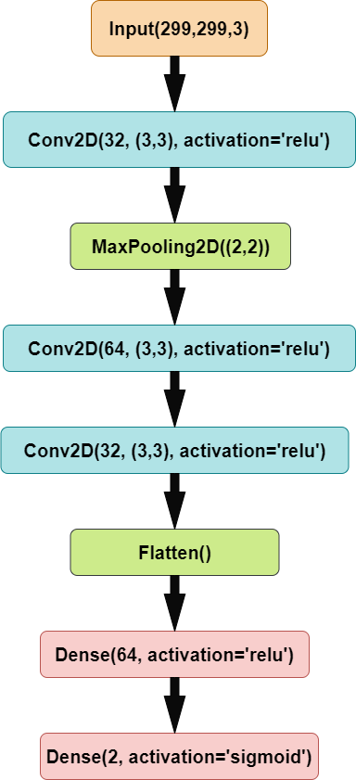
Fig. 3. Customized CNN Architecture

ResNet
ResNet uses skip connections in residual blocks to handle disappearing and bursting gradients, making residual mappings learnable. This makes it possible to effectively train incredibly deep neural networks. ResNet creates residual blocks, which connect layer activations to subsequent levels without going through intermediate layers. By using this method, the network can fit the residual mapping rather than directly learning the underlying mapping. In our case, we used Inception-ResNet-v2 as a feature extractor for the classification between egg damage and no damage. We utilized a pre-trained model from TensorFlow Hub for feature extraction. Later, this was embedded in a sequential model that processed images of size 299x299x3, with a dense layer at the end corresponding to the number of classes. It was trained with the Adam optimizer and Sparse Categorical Cross-entropy for the loss function, with accuracy as the measure; early stopping avoided overfitting by observing the loss and stopping training in case no improvement occurred over three epochs. The model was fit over 13 epochs using an augmented dataset to get a final training accuracy of about 92%. It has an accuracy of 91% when run against the test set, therefore showing that this model could, to a large extent, rightly identify and distinguish a damaged egg from another which is not.
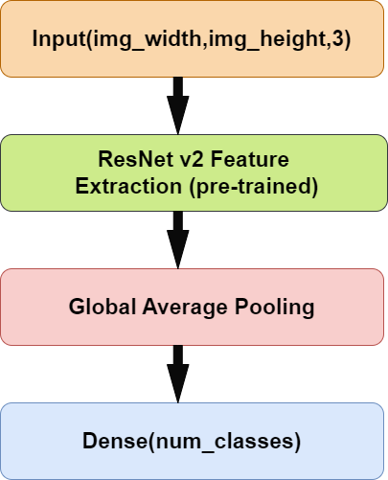
Fig. 4. Resnet Architecture
The image basically shows a deep learning model used in classifying images. The input layer is the first which involves images of shape (img_width, img_height, 3). The pre-trained ResNet v2 model extracts the features. Thereafter, Global Average Pooling reduces the spatial dimensions of the feature maps.

Xception
A convolutional neural network that has been trained to categorize photos into 1000 different object categories is the Xception model. It is particularly good at feature extraction thanks to its” Extreme Inception” architecture, which consists of 36 convolutional layers. The organized flow of Xception is distinct: data moves through entrance, middle, and exit flows, with batch normalization assisting each tier. It is distinguished by having a depth multiplier of 1, which indicates that there is no depth expansion in separate convolution layers. Using its prior knowledge dataset, the model may be refined for use in egg classification such that it can differentiate between eggs that are damaged and those that are not. We used the Xception model to classify the damaged and non-damaged eggs with a pre-trained version on ImageNet. We used the base model as a feature extractor, removing some of the top layers, to process images of size 299x299x3. We appended a global average pooling followed by a dense var wishing for the number of classes. We kept the base model non-trainable to preserve its pre-trained weights. It was then compiled with the Adam optimizer and Sparse Categorical Cross-entropy loss function. This was coupled with an accuracy performance metric. Early stopping monitored the loss to prevent overfitting by stopping training if no improvement was charted in three epochs. The model was fitted over 13 epochs with an augmented dataset to reach a final training accuracy of about 92%. It evaluated to an accuracy of 91% on the test set, which proved that the model is good at classifying damaged versus non-damaged eggs.
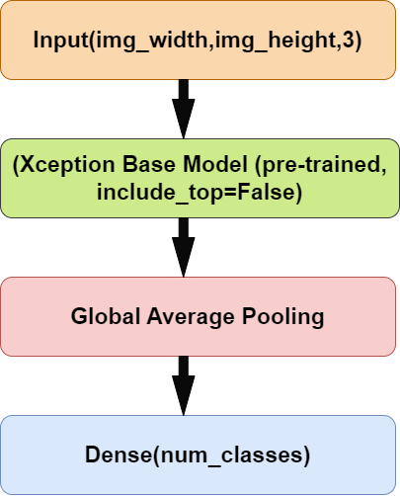

Fig. 5. Xception Model Architecture

This model architecture starts with an input for images of prescribed shape and 3 color channels. Image data is fed into a pre-trained convolutional neural network called the Xception base model. Xception model has a global average pooling layer that compresses the feature maps. After this layer, there is a final dense layer to perform a classification into n classes/user-defined output classes.

RESULTS AND INTERPRETATION
In This study used a variety of deep learning algorithms to analyse photos in order to identify egg cracking and assess if an egg is damaged. Using an egg cracking dataset, the convolutional, Xception and ResNet models was created and used for this challenge. To improve the current dataset, data augmentation techniques were also used.

Dataset Description
The dataset was originally composed of 794 photos, of which 632 were classified as damaged and 162 as not damaged. It is divided into two folders: Damaged and Non-Damaged Eggs. Augmentation techniques were used to improve the dataset, producing a total of 1438 images
The following Table 1 represent the count of samples for each class and the total number of images present in both the original and augmented datasets.
- THE DATASET CONTAINS CLASS-WISE SAMPLES
Class | Original dataset | Augmented Dataset
Non-Damaged | 632 | 937
Damaged | 162 | 501
Total | 794 | 1438

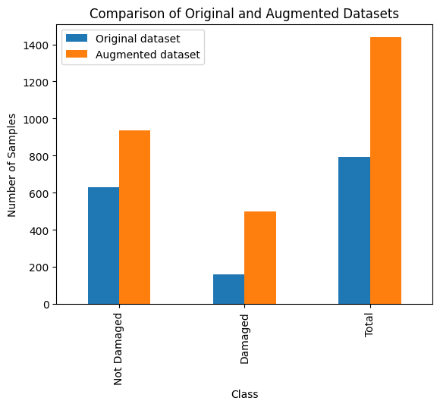
Fig. 6. Class-wise samples in Original and Augmented Datasets

The original dataset for egg crack detection contains 632 undamaged and 162 damaged photos, totaling 794. In contrast, the augmented dataset includes 1438 photos: 937 undamaged and 501 damaged.
- TRAIN AND TEST SPLIT
 | Augmented dataset
Training Set | 1255
Testing Set | 183
Total | 1438

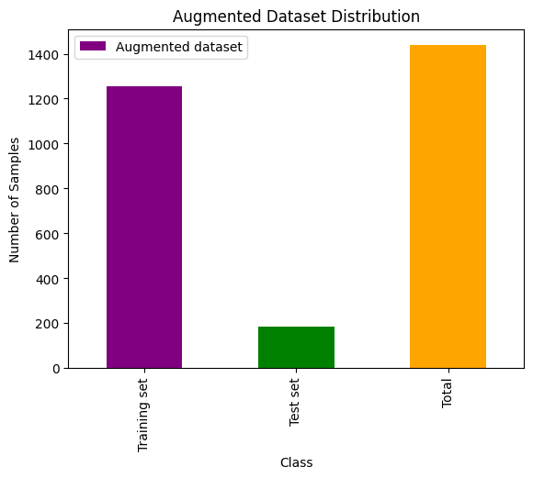
Fig. 7. Augmented Dataset Distribution
The Table consists of the Splitting of Dataset: Training set and Testing set. An overview of an expanded dataset is included in the table, along with the quantity of samples in the training and testing sets. The model is trained using 1,255 samples from the training set. 183 samples make up the testing set, which is used to assess the model's performance. Including both training and testing sets, 1,438 samples make up the entire dataset.

CNN Model
After deploying the custom CNN model on the egg-cracking dataset, the model achieved a test set accuracy of 68.35 percent with a loss of 1.6208. In comparison, the training set accuracy was significantly higher at 94.35 percent, with a loss of 0.06432. These results indicate that while the model performs The experimenting with these approaches, you may be able to improve the model's performance on the test set and reduce the overfitting observed in the initial results.
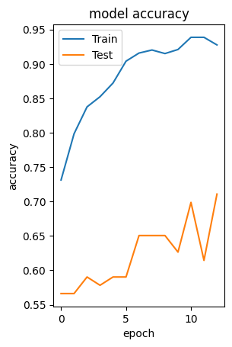
Fig. 8. Validation Accuracy over Epochs

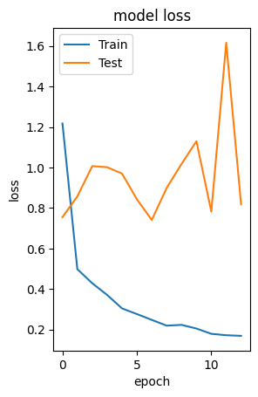

Fig. 9. Validation Loss over Epochs

The above graphs show the accuracy and loss of the model over several epochs for a job of predicting egg cracks. The model accuracy for the training and test sets is displayed on the left graph. The model is learning well from the training data when the training accuracy rises gradually and crosses 0.9. The test accuracy, however, varies between 0.6 and 0.7, which may indicate that the model is overfitting to the training set and underfitting to the test set. The model loss for the training and test sets is shown in the right graph.

ResNet Model
The model achieved an accuracy of 87.35 percent on the test set with a corresponding loss of 0.2608 after applying the ResNet model to the egg-cracking dataset. The model’s performance was better for the training set, with an accuracy of 98.75 percent and a loss of 0.0234. These findings imply that although the model performs poorly on the test set, it is very accurate during training, which may be the result of

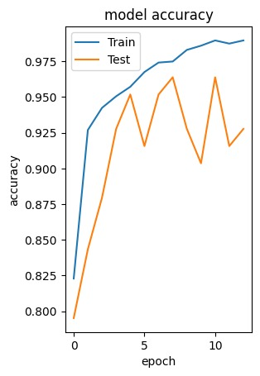
Fig. 10. Validation Accuracy over Epochs

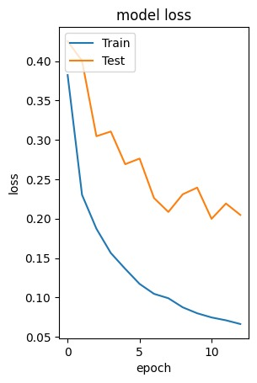
Fig.11. Validation Loss over Epochs

The above graphs represent accuracy and loss of the ResNet model over several epochs included for the prediction of egg cracks. The right graph shows model accuracy for the training and testing sets. The model is learning properly from the training data as the training accuracy increases gradually and crosses 0.95. Insubstantial overfitting to the training set should be noted, as test accuracy ranged from 0.80 to 0.95 for different trials. On the very left, it shows the model loss for both the training and test sets. Training loss does decrease constantly, but the test loss has more fluctuations.

Xception Model

Upon utilizing the Xception model on the egg cracking dataset, the model yielded an accuracy of 89.35 percent on the test set, with a loss of 0.1412. In the training set, the model exhibited a reduced loss of 0.0432 and an increased accuracy of 99.45 percent. As seen by the notable performance disparity between the training and test sets, these findings suggest that while the model functions effectively, there may be some overfitting.
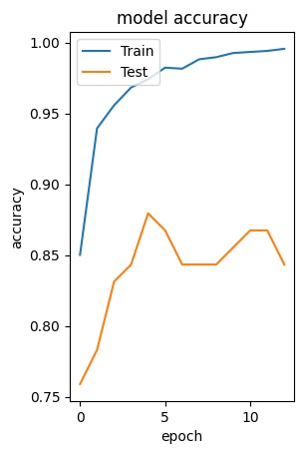
Fig. 12. Validation Accuracy over Epochs

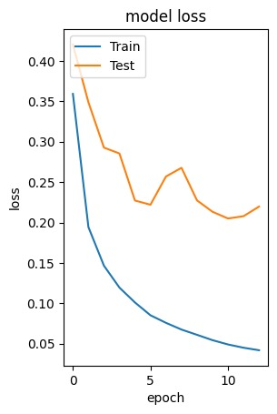
Fig. 12. Validation Accuracy over Epochs

The above graphs indicate the accuracy and loss of the Xception model for a number of epochs in the prediction of egg cracks. The graph on the right represents the accuracy of the model on both the training and test sets. In fact, the model is getting much from the training dataset since training accuracy is gradually increasing to finally cross 0.99. Test accuracy, however, lies in the range from 0.85 to 0.90, which states for the presence of overfitting to the training set. Model loss for the training and test sets; training loss steadily decreases, and test loss is more volatile.

After comparing the models Xception, Resnet, CNN on egg cracking dataset The Xception model performed a efficiently when compared with other models with accuracy 89.33.

Performance Metrics of Each Model
The Table consists of the Performance metrics of each model: Xception, Resnet and CNN. The three model’s performances Xception, ResNet, and CNN are contrasted in the table. With the lowest loss of 0.1412 and the highest accuracy of 89.35%, Xception emerged victorious. ResNet trailed with a loss of 0.2608 and an accuracy of 87.56%. With a far higher loss of 1.6238 and an accuracy of 66.24%, the CNN model performed the worst.
- PERFORMANCE METRICS
Model | Accuracy | Loss
CNN | 66.24 | 0.1412
ResNet | 87.56 | 0.2608
Xception | 89.35 | 1.6238

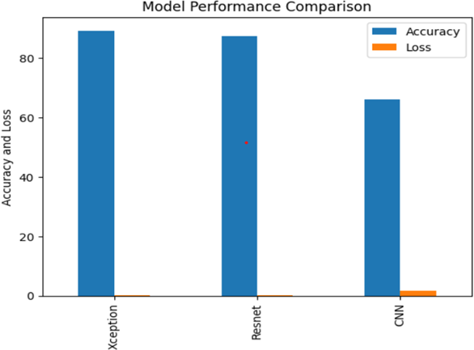

Fig. 13. Performance Metrics of Each Model

Predicted Output for Exception Model
The Xception model satisfactorily forecasts the egg cracking and provides high-precision classification among the classes regarding damaged and non-damaged eggs. For the damaged eggs, the model can detect visible cracks, hence ensuring that such compromised eggs are sorted out and not passed on to consumers, improving food safety. On the other hand, in case of non-damaged eggs, it rightly identifies intact eggs, maintaining a high quality and reducing losses related to breakage. It is in the visual outputs of both classes that real performance is bred for execution in real-world applications. This high accuracy at the stage of classification comes not only to give efficiency to the egg-sorting process but in great measure also assures cost savings and quality control in the egg industry. State-of-the-art deep learning techniques thus back the effectiveness of this model to be effectively applied in automating quality assurance tasks, providing consistent results reliably in food production and processing environments.

The damaged class would be the class that includes cracked or damaged eggs. In a machine learning model, you would train it to classify eggs into one of these classes based on features extracted from images of the eggs.

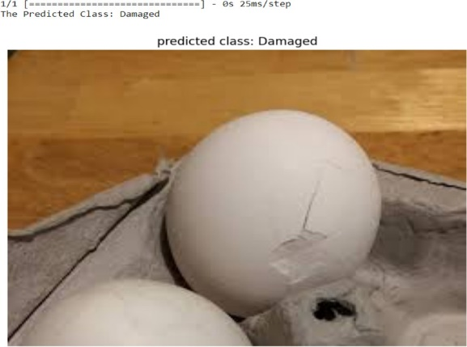

Fig. 11. Output for Damaged Class

The non-damaged class, businesses can optimize their processes to ensure that only high-quality eggs reach consumers, thereby minimizing losses due to breakage and improving quality.

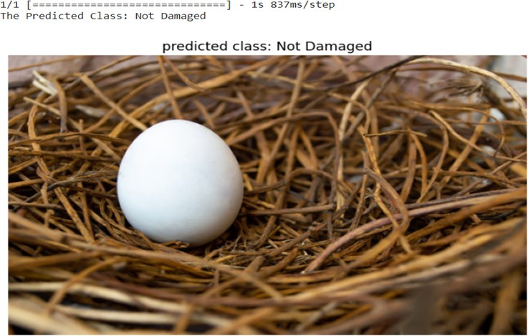

Fig. 11. Output for Non-Damaged Class

CONCLUSION
The study highlights the value of data augmentation in enhancing model accuracy by comparing the effectiveness of several deep learning models for identifying cracks in eggs. The study demonstrates that ResNet achieves the maximum accuracy at 98.75% when CNN, Xception, and ResNet are used. The findings demonstrate the potential of deep learning models for quality control in the egg business, implying that these methods can improve efficiency and economy of scale. The results support more investigation into machine learning for food production’s early detection and quality control.

REFERENCES

